Fig. 1. Map of Bird survey routes conducting in 2006 in Como Park and surrounding area..
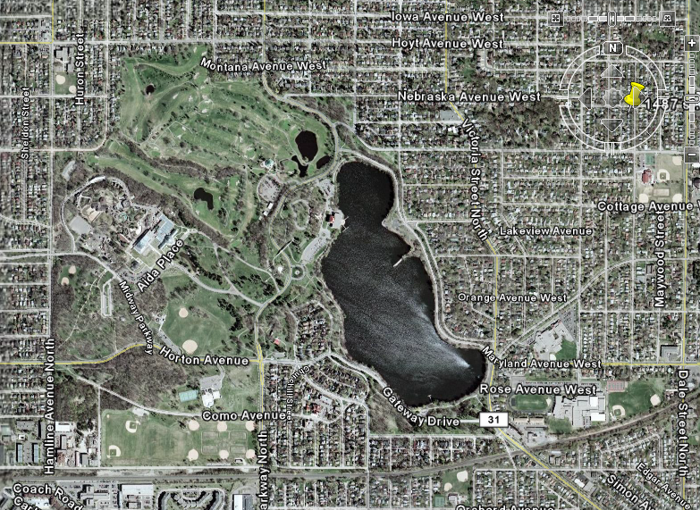
McMurray Fields
NW Como
Mid-Como
Lake
Chatsworth Woods
North Dale
Nebraska Woods
100 200 300 400 500m

